8-amaliy mashg‘ulot.
Ikki o’lchovli signallar ustida filtrlashni amalga oshirish.
Ishning maqsadi: Talabalarga ikki o‘lchovli (2D) signallar — tasvirlar ustida raqamli filtirlashning asosiy tamoyillari va amaliy qo‘llanilishini o‘rgatish.
Nazariy qism: Ikki o‘lchovli signal tushunchasi
Ikki o‘lchovli signal deb matritsa shaklidagi ma’lumotlar to‘plamiga aytiladi. Masalan, tasvir (rasm) piksellari 2D signal hisoblanadi:
𝑓(𝑥,𝑦)
bu yerda x — ustun, y — qator koordinatasi.
2D filtirlashning maqsadi
Tasvirdan shovqinlarni yo‘qotish
Silliqlash (blur) yoki keskinlashtirish (sharpening)
Chegaralarni aniqlash (edge detection)

Topshiriq:
MATLAB ga ikki o‘lchamli signalni import qilish, unga shovqin qo’shish va filtrlash:
% Rasmni o‘qish
I = imread('D://mother.tif'); % MATLABdagi standart rasm
I = im2double(I);

figure;
imshow(I);
title('Asl tasvir');

% a) Salt and pepper shovqini
I_sp = imnoise(I, 'salt & pepper', 0.05);

% b) Gauss shovqini
I_gauss = imnoise(I, 'gaussian', 0, 0.01);

% c) Speckle shovqini
I_speckle = imnoise(I, 'speckle', 0.04);

figure;
subplot(1,3,1), imshow(I_sp), title('Salt & Pepper shovqin');
subplot(1,3,2), imshow(I_gauss), title('Gauss shovqin');
subplot(1,3,3), imshow(I_speckle), title('Speckle shovqin');

h = fspecial('average', [3 3]);
I_avg = imfilter(I_sp, h, 'replicate');

h_gauss = fspecial('gaussian', [5 5], 1.0);
I_gauss_filtered = imfilter(I_sp, h_gauss, 'replicate');

figure;
subplot(2,2,1), imshow(I_sp), title('Shovqinli rasm');
subplot(2,2,2), imshow(I_avg), title('O‘rtacha filtr');
subplot(2,2,3), imshow(I_gauss_filtered), title('Gauss filtr');

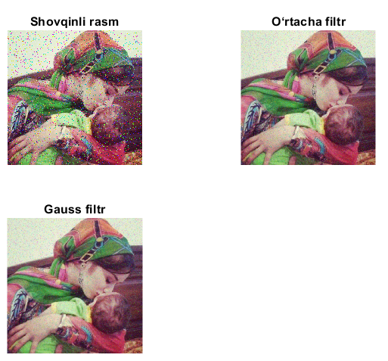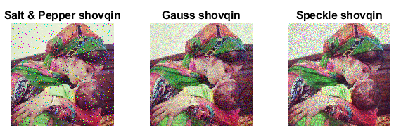
- MATLAB ga ikki o‘lchamli signalni import qiling, variant asosida unga shovqin qo’shing va filtrlang.
Hisobot tarkibi.
- Natijalar (skrinshot ko’rinishida).
- Xulosa.

Nazorat savollari:
- Filtrlash nima va uning maqsadi nimadan iborat?
- Past chastotali va yuqori chastotali filtrlar o‘rtasidagi farq nimada?
- Gauss filtr qanday holatlarda ishlatiladi?
- Filtrlash natijasini grafik asosida qanday tahlil qilish mumkin?

